**Report Compiler Construction Lab Project 1B: Extended Lexical Analyzer**

Name: Hoàng Thanh Lâm

ID: 20194786

Result of running the scanner project with example2.kpl :

1. Case Identifiers:

The first letter of an identifier should be either a letter or an underscore

And only 15 characters are significant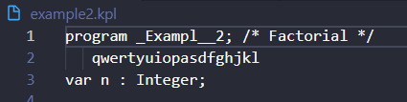

The result is:

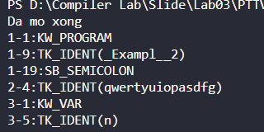

1. Case Keywords: All keywords must be written in lowercase:

program is keywords

Function is not keywords because it written in both lowercase and

uppercase.

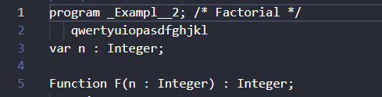

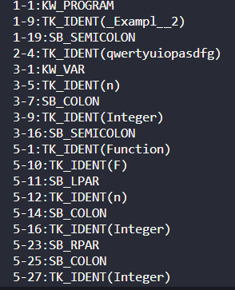

1. Case Comments: Multi-line Comments : between /* and */

Already showed in picture case 2.

1. Case Special Symbols: Assign operator =, relop: equal to == :

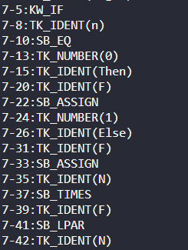

1. Case : Character/String constants: Use an addition character \ for 2 constants single quote and backslash, that is ‘\’’ for a single quote and ‘\\’for backslash :

